**Installing Packages in Microsoft VISTA operating environment.**

In order to install the MASS and XLSReadWrite packages, you have to run R as an administrator. To do this, you must run R from the “Start” button in the bottom left hand corner of the screen. Use the right button on the mouse to start, and select “Run as Administrator” from the screen, as shown in the figure below. If you do not run R as Administrator in this way, the VISTA operating system will not allow the packages to be installed into R.

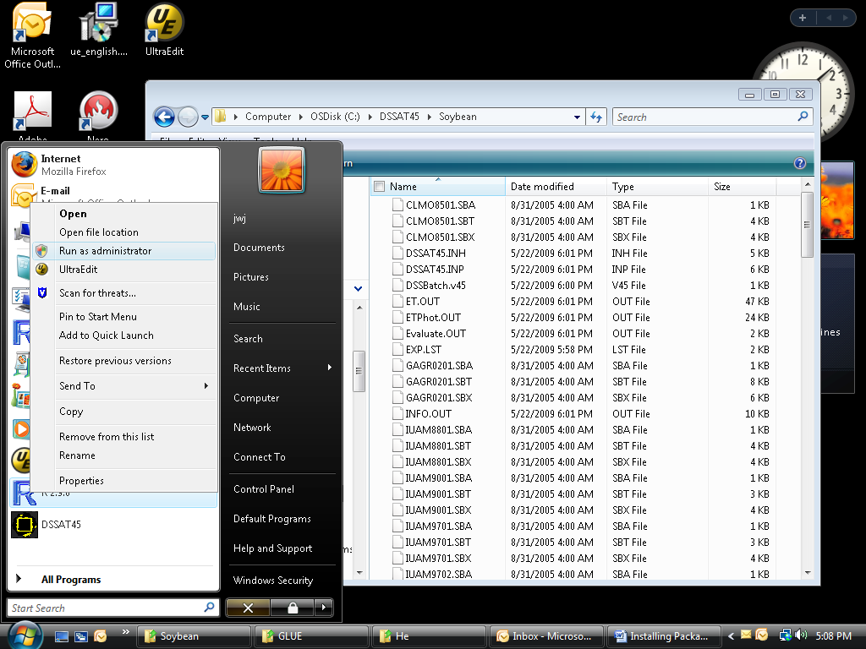

**Running GLUE**

Before running GLUE, you may want to “Disable On-Access Scan) of your virus software. The program will operate much faster by doing this before running GLUE, as much as 5 or more times faster. GLUE runs may take some time, possibly from 0.5 – 2 hours, depending on how many seasons are selected for estimating the coefficients.